kırpıntı çizim, simge, sembol, grafik, tasarım içeren bir resim

Açıklama otomatik olarak oluşturuldu

MIDDLE EAST TECHNICAL UNIVERSITY

ELECTRICAL & ELECTRONICS ENGINEERING

2024-2025 FALL

EE463 – STATIC POWER CONVERSION I

HARDWARE PROJECT

SIMULATION REPORT

24.11.2024

Muhammet Kamer Taha GENÇ 2234748

Mustafa Burak ÇORUK 2442812

Öykü KAYAN 2516391

**Table of Contents**

**Introduction** 2

**Problem Definition** 3

**Topology Options** 3

**1)** **Single Phase Diode Rectifier with Buck Converter** 3

**2)** **Three Phase Diode Rectifier with Buck Converter** 5

**Topology Selection** 7

**Simulation Results** 8

**1)** **Three Phase Diode Rectifier Simulation** 8

**2)** **Buck Converter Simulation** 8

**3)** **Three Phase Diode Rectifier and Buck Converter Simulation** 8

**4)** **Controller Simulation** 8

**Component Selection** 8

**Conclusion** 8

**References** 8

**Introduction**

This project focuses on designing a DC motor drive system using a controlled rectifier to convert AC grid input into an adjustable DC output. The report evaluates two topologies: single-phase and three-phase diode rectifiers with buck converters, assessing their performance through simulations. Based on the results, the optimal topology is selected, and suitable components are identified. This simulation-based analysis lays the groundwork for future hardware implementation, ensuring the design meets performance and stability requirements before the prototyping phase.

**Problem Definition**

This project aims to design a controlled rectifier to power a DC motor by converting AC grid input (single-phase or three-phase) into adjustable DC output (up to 180 V).

**Key Requirements**:

* **Input**: Single-phase or three-phase AC (adjustable via variac)
* **Output**: Adjustable DC voltage, maximum 180 V
* **Topologies**: Options include:
* Single-phase diode rectifier + buck converter
* Three-phase diode rectifier + buck converter
* **Motor Specs**:
* Armature: 0.8 Ω, 12.5 mH
* Shunt: 210 Ω, 23 H
* Interpoles: 0.27 Ω, 12 mH

**Topology Options**

In designing a controlled rectifier to drive a DC motor, various topologies can be considered to convert the AC grid input into an adjustable DC output. The primary objective is to ensure a stable and efficient DC voltage for reliable motor operation. For this purpose, two alternative topologies are the single-phase diode rectifier with buck converter and the three-phase diode rectifier with buck converter, each with its own set of advantages and limitations. These topologies are discussed in detail below.

1. **Single Phase Diode Rectifier with Buck Converter**

In this configuration, the single-phase AC input is first rectified by the diode rectifier, converting the AC into DC, as shown in Figure 1. The output of the rectifier is then processed by the buck converter, shown in Figure 2, which steps down the DC voltage to the desired level.

diyagram, teknik çizim, çizgi, taslak içeren bir resim

Açıklama otomatik olarak oluşturuldu

Figure 1: Single Phase Diode Rectifier Circuit

The first stage of the system involves converting the AC input into DC. This is done using a single-phase diode rectifier. In a single-phase full-wave rectifier, the diodes are arranged to rectify both the positive and negative halves of the AC waveform.

The output of the rectifier is a pulsating DC voltage. The average DC output voltage, which is the DC equivalent of the rectified signal, can be calculated using the following formula:

$$V_{out}= \frac{2\sqrt{2}}{π}×V_{phase}$$

However, the output voltage is still not pure DC, as it contains ripples corresponding to the AC input frequency. These ripples may affect the performance of the motor, which is why further smoothing, and regulation are needed in the next stage.

diyagram, taslak, teknik çizim, plan içeren bir resim

Açıklama otomatik olarak oluşturuldu

Figure 2: Buck Converter Circuit

A buck converter processes the resultant DC voltage after rectification to lower it to the required level. Buck converters are an example of DC-DC converter that reduces the DC voltage. In order to create a steady, lower DC voltage, it first converts the DC input into a high-frequency pulse using a switching device. Then, inductor and capacitor filter the pulse.

The duty cycle D of the buck converter, which is the ratio of the switch's on-time to the overall switching cycle period, determines the output voltage. The output voltage formula is as follows:

$$V_{out}= D×V_{in}$$

Overall formula for the system is:

$$V_{out}=D×\frac{2\sqrt{2}}{π}×V_{phase}$$

**Advantages**

* The single-phase diode rectifier is a straightforward solution to convert AC to DC, requiring fewer components than three-phase alternatives.
* Due to fewer components, the single-phase configuration is generally cheaper to implement.
* This configuration provides a straightforward yet efficient solution for smaller motors and is ideal for low-power DC motor applications.
* With fewer diodes in the conduction path, single-phase systems experience lower voltage drops across the diodes compared to three-phase systems, leading to lower conduction losses at lower current levels.

**Disadvantages**

* There are ripples in the rectified DC output that could affect motor performance, necessitating extra filtering and regulation steps.
* Compared to three-phase rectifiers, single-phase rectifiers are less effective at higher power levels.

1. **Three Phase Diode Rectifier with Buck Converter**

This configuration involves two stages: the three-phase diode rectifier and the buck converter, working together to efficiently convert and regulate the voltage supplied to the DC motor.

diyagram, çizgi, teknik çizim, plan içeren bir resim

Açıklama otomatik olarak oluşturuldu

Figure 3: Three Phase Diode Rectifier Circuit

Each of the three sinusoidal AC waveforms in a three-phase system is 120 degrees out of phase with the others. The rectifier transforms the three-phase AC input into pulsating DC by allowing current to flow through the circuit in a single direction using six diodes placed in a bridge arrangement.

The output of the three-phase rectifier is pulsating DC, and the average DC voltage is given by:

diyagram, taslak, teknik çizim, plan içeren bir resim

Açıklama otomatik olarak oluşturuldu

Figure 4: Buck Converter Circuit

Following the three-phase diode rectifier's correction of the DC voltage, the output still requires regulation and control. A buck converter, which lowers down the DC voltage to the required level, is used to do this. The formula for the output voltage is:

$$V_{out}= D×V_{in}$$

Overall formula for the system is:

$$V_{out}=D×\frac{3\sqrt{2}}{π}×V_{linetoline}$$

**Advantages**

* The output voltage from a three-phase rectifier is higher compared to a single-phase rectifier for the same input AC voltage.
* The DC output of a three-phase rectifier is smoother than that of a single-phase rectifier because it generates less ripple. This is critical for efficient and reliable motor performance, especially at higher loads.
* By better utilizing the available AC input, the three-phase system improves efficiency and regulates the DC output. For DC motor applications, where steady power delivery is crucial, this is especially advantageous.
* Three-phase rectifiers are better for larger DC motors or applications needing larger amounts of energy production since they can manage higher power levels more effectively. Performance is enhanced and energy losses are decreased as a result.

**Disadvantages**

* Compared to the single-phase option, the three-phase diode rectifier system is more complicated. To handle the three-phase AC input, it needs more parts, including six diodes and more circuitry, which extends the design time and complicates the system.
* The system is more costly to implement due to the higher number of diodes and components.
* With more diodes in the conduction path, a three-phase full-bridge rectifier experiences greater total voltage drops across the diodes during operation.

**Topology Selection**

After carefully evaluating the advantages and disadvantages of both the single-phase diode rectifier with buck converter and the three-phase diode rectifier with buck converter, the decision was made to choose the three-phase diode rectifier with buck converter topology for the motor drive application.

**Higher Output Voltage**: The three-phase rectifier provides a higher DC output voltage, making it suitable for high-power motor applications.

**Smoother DC Output**: Compared to the single-phase rectifier, the three-phase system produces less ripple in the DC output, ensuring stable motor performance and efficiency.

**Increased Efficiency**: The three-phase system is more efficient for high-power applications, minimizing losses and improving overall system performance.

**Simulation Results**

Component selection process for the simulations are going like that:

First, select proper components for three phase diode rectifier and simulate it. (We have chosen the components according to HW-1 of the EE463 course) If results are good enough, keep the components as they are.

Second, select proper components for buck converter and simulate it. We have chosen the components to be able to decrease the output voltage to 180 max which is mainly duty cycle dependent (controller selection is important), and also efficiency of the component dependent such as efficiency of MOSFET, diode, inductor and capacitor. Formula for keeping the output voltage at 180V is: Vd*D*efficiency = Vo

Inductance, capacitance and resistance selection is also important for simulation of the buck converter. Resistance is selected as 20 ohms which is neither low nor high. R is important for DCM and CCM working style (which has a formula: Lmin = (1-D)*R/2fs ), we try to keep operation style as CCM. Frequency of the MOSFET switching also has an effect on this election since ‘fs’ has an effect on the minimum inductance of the buck converter. Switching frequency also has effect on inductance, capacitance, inductance current and output voltage ripple:

yazı tipi, beyaz, metin, simge, sembol içeren bir resim

Açıklama otomatik olarak oluşturuldu

yazı tipi, beyaz, metin, diyagram içeren bir resim

Açıklama otomatik olarak oluşturuldu

yazı tipi, metin, beyaz, tasarım içeren bir resim

Açıklama otomatik olarak oluşturuldu

yazı tipi, metin, beyaz, tipografi içeren bir resim

Açıklama otomatik olarak oluşturuldu

While we were researching the switching frequency, we saw that the switching frequency is set at 20-30 kHz for some application (semi-professional application like ours). Therefore, we arrange the switching frequency as 25 kHz. The first parameter that we can arrange is ripple of the inductance current because it depends on the duty cycle, output voltage, switching frequency and inductance. Since we can take 9.1 A average inductance current (for indicated duty cycle which comes from Vd*D*efficiency = Vo efficiency seems 0.995 for these values, but it will change for real application and real components. Simulations for real components values also will be showed in this report and final report) we required 1-1.5 A ripple. So, 0.5=180*(1-0.65)/(25000*L) and L = 3 mH. Capacitor can be calculated after L is set. We should know the voltage ripple now. Since our desired output voltage is 180 V and we do not require voltage ripple more than 2.5% (%2.5*180 = 4.5 V): C = 1.5/(8*25000*4.5 = 1.7 uF) We set it as 3 uF to be able to satisfy corner frequency. Corner Frequency is the frequency at which the response of a system (such as a filter, amplifier, or control system) begins to decline or change.[1]

Equation of it is

yazı tipi, beyaz, metin, grafik içeren bir resim

Açıklama otomatik olarak oluşturuldu

Since we discussed this topic in EE463 lectures, we know that we need to arrange corner frequency less than switching frequency to be able to keep our components in safe area. At the beginning of the power flow process there might be ringing, and we should be careful about the corner frequency point because (sometimes) there also may be ringing at that point. Since circuit voltage and current are ringing during power flow starting point, if gain of the filter also become higher value than expected (because of the ringing at the corner frequency point), we may see huge amount of voltage and current which will be much more than we expect and arrange.

Corner frequency for our buck converter is fc= 1/(6.28*(3*10-3*3*10-6)1/2) = 1677 Hz

1. **Three Phase Diode Rectifier Simulation**

**diyagram, plan, teknik çizim, çizgi içeren bir resim

Açıklama otomatik olarak oluşturuldu**

Figure a. Three phase diode rectifier circuit

FIGURES B1-C1-D1 ARE FOR CONFIGURATION ACCORDING TO EE463 HW 1

metin, ekran görüntüsü, yazı tipi, sayı, numara içeren bir resim

Açıklama otomatik olarak oluşturuldu

Figure b1. Diode rectifier diodes voltage and current vs time waveform.

metin, ekran görüntüsü, yazı tipi, öykü gelişim çizgisi; kumpas; grafiğini çıkarma içeren bir resim

Açıklama otomatik olarak oluşturuldu

Figure c1. Output voltage and input phase current vs time waveform.

metin, ekran görüntüsü, yazı tipi, çizgi içeren bir resim

Açıklama otomatik olarak oluşturuldu

Figure d1. Output voltage and input phase current vs time waveform from closer perspective.

FIGURE B-C-D ARE FROM THE CIRCUITS PARAMETERS ACCORDING TO RESULTS OF DIODE RECTIFIER+BUCK CONVERTER CIRCUIT

**metin, ekran görüntüsü, yazı tipi, sayı, numara içeren bir resim

Açıklama otomatik olarak oluşturuldu**

Figure b. Diode rectifier diodes voltage and current vs time waveform.

**metin, öykü gelişim çizgisi; kumpas; grafiğini çıkarma, çizgi, ekran görüntüsü içeren bir resim

Açıklama otomatik olarak oluşturuldu**

Figure c. Output voltage and input phase current vs time waveform.

**metin, ekran görüntüsü, öykü gelişim çizgisi; kumpas; grafiğini çıkarma, çizgi içeren bir resim

Açıklama otomatik olarak oluşturuldu**

Figure d. Output voltage and input phase current vs time waveform from closer perspective.

1. **Buck Converter Simulation**

metin, yazı tipi, ekran görüntüsü, tasarım içeren bir resim

Açıklama otomatik olarak oluşturuldu

Figure ba. MOSFET Drain to Source Voltage and Current vs Time Plot of the Buck Converter.

metin, ekran görüntüsü, yazı tipi, tasarım içeren bir resim

Açıklama otomatik olarak oluşturuldu

Figure bb. Diode Voltage and Current vs Time Plot of the Buck Converter.

metin, ekran görüntüsü, yazı tipi, çizgi içeren bir resim

Açıklama otomatik olarak oluşturuldu

Figure bc. Inductance Voltage, Output Voltage and Inductance Current vs Time Plot of the Buck Converter.

metin, ekran görüntüsü, yazı tipi, tasarım içeren bir resim

Açıklama otomatik olarak oluşturuldu

Figure bd. Inductance Voltage, Output Voltage and Inductance Current vs Time Plot from closer perspective of the Buck Converter.

1. **Three Phase Diode Rectifier and Buck Converter Simulation**

**diyagram, plan, teknik çizim, şematik içeren bir resim

Açıklama otomatik olarak oluşturuldu**

Figure x. Connected circuit of three phase diode rectifier and buck converter (non-ideal conditions).

ekran görüntüsü, metin, çizgi içeren bir resim

Açıklama otomatik olarak oluşturuldu

Figure y. Phase a Input Current and Output Voltage vs Time Plot of the three phase diode rectifier.

**metin, ekran görüntüsü, yazı tipi, çizgi içeren bir resim

Açıklama otomatik olarak oluşturuldu**

Figure z. Closer perspective for input phase current and output voltage of the three-phase diode rectifier after power flow starts and circuit become stable.

**metin, ekran görüntüsü, çizgi, öykü gelişim çizgisi; kumpas; grafiğini çıkarma içeren bir resim

Açıklama otomatik olarak oluşturuldu**

Figure a. Inductance Voltage and Output Voltage and Inductance Current vs Time Plot of the buck converter.

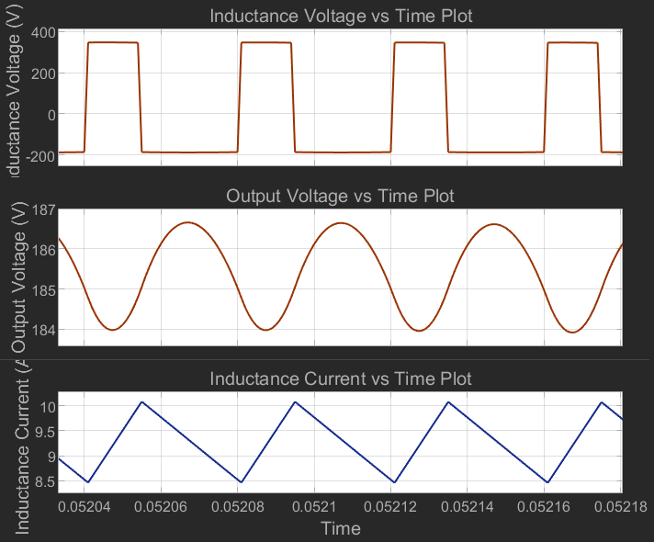

Figure b. Closer perspective for inductance voltage, output voltage and inductance current of the buck converter after power flow starts and circuit become stable.

**metin, ekran görüntüsü, yazı tipi, piyano içeren bir resim

Açıklama otomatik olarak oluşturuldu**

Figure c. Diode Voltage and Diode Current vs Time plot for the three-phase diode rectifier.

metin, ekran görüntüsü, öykü gelişim çizgisi; kumpas; grafiğini çıkarma, çizgi içeren bir resim

Açıklama otomatik olarak oluşturuldu

Figure e. Buck converter diode voltage and current vs time plot.

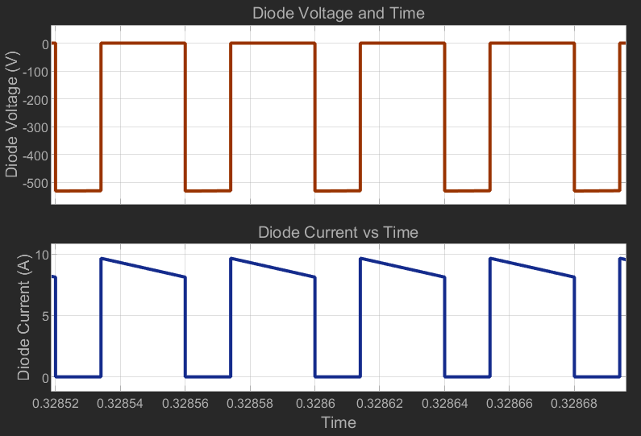

Figure d. Buck converter diode voltage and current vs time plot after circuit become stable.

1. **Controller Simulation**

**Component Selection**

**Conclusion**

**References**

[1] "Cutoff frequency," *Wikipedia*. [Online]. Available: <https://en.wikipedia.org/wiki/Cutoff_frequency>. [Accessed: 16-Nov-2024].